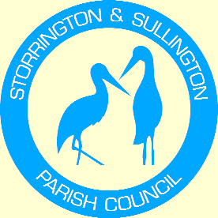
Storrington, Sullington and Washington
Neighbourhood Plan

WASHINGTON
PARISH COUNCIL

You are duly summoned to attend the Meeting to be held in The Chanctonbury Room, The Parish Hall, Thakeham Road, Storrington, on Tuesday, 19th September 2023 at 6.30pm.

A G E N D A

- Apologies for Absence.

- To Approve and sign the Minutes of the last Meeting of the Steering Group on 8th March 2022.

- Horsham District Local Plan – To Consider approach to meeting with HDC representatives about Sites included in the Plan.

- Storrington & Sullington and Washington Neighbourhood Plan: To Consider future validity of the Plan following HDC’s decision to approve DC/23/0701 – Old Clayton Boarding Kennels, Storrington Road, Washington.

- Any other business.

TJ Euesden

Tracey Euesden
Clerk to Storrington & Sullington Parish Council 14/09/2023

Members: Councillors Anna Worthington-Leese, Richard Jerman, Lisa Wheatley (SSPC)
Councillors Patrick Heeley, Trevor Keech, Tony Lisher (WPC)

